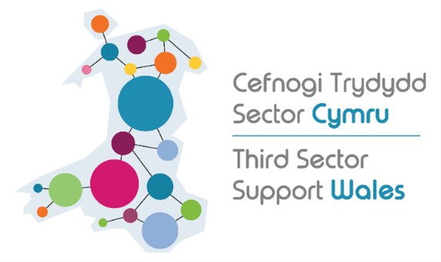
Volunteering Wales campaign pack

Introduction
Volunteering Wales is a website that connects people that want to volunteer in Wales with charities and other organisations in the Welsh voluntary sector. It’s been designed specifically by and for Welsh organisations and is fully bilingual. It supports organisations from all kinds of sectors that are looking for volunteers, including public/statutory bodies like local authorities, health boards, police forces and more.
Volunteering Wales is free to use and an extremely accessible way to grow a volunteer base or connect people with the voluntary sector. Since its relaunch it has continued to be improved and refined to better help organisations attract new volunteers to their cause. Everyone’s time is precious, especially in the context of the cost of living crisis, so our aim is to make volunteering as simple and accessible as possible so volunteers and organisations can find each other with minimum fuss.
Throughout this pack we have provided materials aimed at informing both volunteers and organisations that work with volunteers about Volunteering Wales.
We know the sector is facing a volunteer recruitment crisis at the moment, so we want to use Volunteering Wales to do what we can to help and make sure as many organisations and potential volunteers are aware of its benefits as possible. Thanks for your help in getting the word out.

Campaign pack

In this pack, you’ll find:

- Example social media posts (English & Welsh)
- Sample text for emails or articles
- Graphics for social media
The content is divided into materials aimed at our two different audiences:

- Attracting organisations
- Attracting volunteers

Please feel free to chop and change the content to suit the audience / person you’re sending it to.

Attracting organisations

- Example social media posts

English | Cymraeg
Volunteering Wales is a simple, effective and completely free way to recruit volunteers for your organisation. Reach new people all over Wales and register today at https://volunteering-wales.net/ | Mae Gwirfoddoli Cymru yn ffordd syml, effeithiol, rhad ac am ddim o recriwtio gwirfoddolwyr ar gyfer eich mudiad. Er mwyn cyrraedd pobl o bob rhan o Gymru, cofrestrwch heddiw yn https://gwirfoddolicymru.net/
Volunteering Wales is a great way to demonstrate what volunteering with your organisation can do for people, and it’s quick and easy for volunteers to sign up to. Reach volunteers no matter where you are in Wales and sign up today https://volunteering-wales.net/ | Mae Gwirfoddoli Cymru yn ffordd wych o ddangos beth all gwirfoddoli gyda’ch mudiad ei gynnig i bobl, ac mae’n hawdd a chyflym i wirfoddolwyr gofrestru ar. Gallwch gyrraedd gwirfoddolwyr waeth ble yng Nghymru ydych chi, cofrestrwch heddiw https://gwirfoddolicymru.net/
With the ongoing crisis in volunteer recruitment, advertise your opportunities through the free, easy to use Volunteering Wales platform. It’s a hassle-free way to attract volunteers to your cause from all over Wales. Show people what volunteering can do for them and register to advertise your opportunities https://volunteering-wales.net/ | Gyda’r argyfwng recriwtio gwirfoddolwyr parhaus, hysbysebwch eich cyfleoedd drwy lwyfan am ddim a hwylus Gwirfoddoli Cymru. Mae’n ffordd ddi-ffwdan o ddenu gwirfoddolwyr at eich achos o bob rhan o Gymru. Dangoswch i bobl beth all gwirfoddoli ei gynnig iddyn nhw, a chofrestrwch i hysbysebu eich cyfleoedd https://gwirfoddolicymru.net/
Are you looking for free, quick, and easy ways to promote your volunteering opportunities across Wales? Take a look at Volunteering Wales to reach volunteers all across the country  https://volunteering-wales.net/ | Ydych chi’n chwilio am ffyrdd hawdd, cyflym ac am ddim o hyrwyddo eich cyfleoedd gwirfoddoli ledled Cymru? Cymerwch gipolwg ar wefan Gwirfoddoli Cymru i gyrraedd gwirfoddolwyr ledled y wlad  https://gwirfoddolicymru.net/
Do you work through Cymraeg? Volunteering Wales is a fully bilingual service that makes recruiting Welsh speaking volunteers hassle free https://volunteering-wales.net/ | Ydych chi’n gweithio trwy gyfrwng y Gymraeg? Mae Gwirfoddoli Cymru yn wasanaeth cwbl ddwyieithog sy’n ei gwneud hi’n hawdd recriwtio gwirfoddolwyr sy’n siarad Cymraeg. https://gwirfoddolicymru.net/
Volunteering Wales is the only national, fully bilingual volunteering platform in Wales – register today to start finding volunteers: https://volunteering-wales.net/ | Gwirfoddoli Cymru yw'r unig blatfform gwirfoddoli cenedlaethol, hollol ddwyieithog yng Nghymru – cofrestrwch heddiw i ddechrau dod o hyd i wirfoddolwyr: https://gwirfoddolicymru.net/

- Sample text

Email:

[Subject] Volunteering Wales helps Welsh organisations reach volunteers
Volunteering Wales is a free to use website managed by TSSW (Third Sector Support Wales) that connects volunteers with the voluntary organisations that need them, and it couldn’t be simpler to take advantage of it.
VOLUNTEERING MADE EASY
Whether you’re looking for volunteers to work in charity shops, take part in befriending services or helping organise charity runs and events, Volunteering Wales is a simple and effective way to find and engage with volunteers.
Volunteers are the backbone of the voluntary sector. At a time when both the public and voluntary sector are pushed for time and money, Volunteering Wales makes the process simple and straightforward, so you can find your volunteers with the minimum amount of fuss.
RECRUITING VOLUNTEERS
Using volunteers time as match funding can be an important part of applying to funders, and Volunteering Wales allows you to quickly and easily record those hours. It can also help to develop people’s skills, and being an online platform means it’s more accessible for people wherever they are, whatever their needs.
The site is fully functional and fully bilingual on mobile, tablet and desktop, and it can tell volunteers what’s available locally wherever they happen to be. This means they can find out what’s going on and manage and access their opportunities even when they’re on the move.
With the ongoing crisis in volunteering recruitment, Volunteering Wales is an easy and hassle-free way to attract volunteers – register your organisation for free today.

News article:
Volunteering Wales connects Welsh volunteers to the organisations that need them
Volunteering Wales is a simple, effective and completely free digital platform for Welsh organisations to recruit volunteers.
Managed by TSSW (Third Sector Support Wales), Volunteering Wales links volunteers with the voluntary organisations that need them, and it couldn’t be simpler to take advantage of it.
VOLUNTEERING MADE EASY
It’s free to use, and your organisation can join the many others who are advertising volunteering opportunities to the Welsh public.
Wales has a rich history of volunteering, in all the different forms it takes, and now it couldn’t be easier for people to help out in their local communities. Organisations are advertising all sorts of volunteer opportunities all across the country, from working in charity shops, to befriending services, helping organise charity runs and events and more.
Whether you’re an organisation looking for new volunteers, or someone who wants to give back to their community, Volunteering Wales can help you find what you need.
Volunteers are the backbone of the voluntary sector, and at a time when many are pushed for time and money, Volunteering Wales makes the process simple and straightforward so you can find volunteers with the minimum amount of fuss.
RECRUITING VOLUNTEERS
Volunteering Wales allows you to directly demonstrate what volunteering for your organisation can do for people, and it’s a straightforward way for volunteers to sign up and record their volunteering activities.
Using volunteers time as match funding can be an important part of applying to funders, and Volunteering Wales allows you to quickly and easily record those hours. It can also help to develop people’s skills, and being an online platform means it’s more accessible for people wherever they are, whatever their needs.
The site is fully functional and fully bilingual on mobile, tablet and desktop, and it can tell volunteers what’s available locally wherever they happen to be. This means they can find out what’s going on and manage and access their opportunities even when they’re on the move.
You’ll also gain access the support and expertise of the TSSW network, connecting you with volunteer centres and experts in your area.
With the ongoing crisis in volunteering recruitment, Volunteering Wales is an easy and hassle-free way to attract and manage volunteers – register your organisation for free today.

Attracting volunteers

- Example social media posts

English | Cymraeg
Want to volunteer but don’t know where to start? Volunteering Wales connects volunteers with charities and other organisations – sign up for free: https://volunteering-wales.net/ | Eisiau gwirfoddoli ond ddim yn siŵr ble i ddechrau? Mae Gwirfoddoli Cymru yn cysylltu gwirfoddolwyr gydag elusennau a mudiadau eraill – cofrestrwch am ddim: https://gwirfoddolicymru.net/
Want to do something positive in your community? Volunteering Wales connects volunteers and voluntary organisations – sign up for free: https://volunteering-wales.net/ | Eisiau gwneud rhywbeth cadarnhaol yn eich cymuned? Mae Gwirfoddoli Cymru yn cysylltu gwirfoddolwyr a mudiadau gwirfoddol – cofrestrwch am ddim: https://gwirfoddolicymru.net/
Volunteering Wales is a quick and easy way to search for volunteering opportunities that suit you: https://volunteering-wales.net/ | Mae Gwirfoddoli Cymru yn ffordd hawdd a chyflym o chwilio am gyfleoedd gwirfoddoli sy’n addas i chi: https://gwirfoddolicymru.net/
Volunteering can be a great way of improving your skills and learning new things while giving something back. Register for free today: https://volunteering-wales.net/ | Gall gwirfoddoli fod yn ffordd wych o wella eich sgiliau a dysgu pethau newydd wrth roi rhywbeth yn ôl. Cofrestrwch am ddim heddiw: https://gwirfoddolicymru.net/
Volunteering can be a great way of improving your skills and learning new things while giving something back. Ever fancied getting into jewellery care or being someone’s gig buddy? Volunteering Wales has these opportunities and more! Register for free today: https://volunteering-wales.net/ | Gall gwirfoddoli fod yn ffordd wych o wella eich sgiliau a dysgu pethau newydd wrth roi rhywbeth yn ôl. Ydych chi awydd rhoi cynnig ar lanhau gemwaith neu fod yn gyfaill gig? Mae gan Gwirfoddoli Cymru y cyfleoedd yma a mwy! Cofrestrwch am ddim Heddiw: https://gwirfoddolicymru.net/
Are you passionate about a cause – the environment, animals, health, welfare? Volunteering Wales is a quick and easy way to search for volunteering opportunities that interest you  https://volunteering-wales.net/ | Ydych chi’n angerddol am achos – yr amgylchedd, anifeiliaid, iechyd, lles? Mae Gwirfoddoli Cymru yn ffordd hawdd a chyflym o chwilio am gyfleoedd gwirfoddoli sydd o ddiddordeb i chi  https://gwirfoddolicymru.net/

- Sample text

Email:

[Subject] Volunteering Wales is a quick and easy way to find the volunteering opportunities that suit you
Volunteering Wales is a website managed by TSSW (Third Sector Support Wales) that connects volunteers based in Wales with the voluntary organisations that need them, and it couldn’t be simpler to take advantage of it.
VOLUNTEERING MADE EASY
It’s free for anyone to use, and with over a thousand organisations already on board, once you register it’s a straightforward case of searching from the list of opportunities available in your area.
Organisations are advertising all sorts of volunteer opportunities all across the country, from working in charity shops, to unique experiences like jewellery care or being a gig buddy for adults with learning disabilities. If you want to make a difference in your community but don’t know where to start, Volunteering Wales is the place to go.
ON HAND WHEN THEY NEED TO BE
Volunteers are the backbone of the voluntary sector, and at a time when many are pushed for time and money, Volunteering Wales aims to make your experience as smooth and rewarding as possible. What’s more, it’s something you could do from the comfort of your own home, with many organisations offering remote or other accessible volunteering opportunities.
The site is fully functional on mobile, tablet and desktop, and it can tell you what sort of opportunities are available locally wherever you happen to be, so you can find out what’s going on even when you’re on the move.
GIVE BACK, GAIN SOMETHING
There are many benefits to volunteering. It can be a way of meeting new people, developing new skills or improving your confidence. Volunteering Wales can be your gateway to a new, rewarding experience – register for free, today.

News article:
Find volunteering opportunities that suit you with Volunteering Wales
Want to volunteer but don’t know where to start? Volunteering Wales can connect you with the organisations that need you.
Volunteering Wales is free for anyone to use, and already used by hundreds of organisations to advertise their volunteering opportunities, and it couldn’t be simpler to register.
VOLUNTEERING MADE EASY
Wales has a rich history of volunteering, in all the different forms it takes, and now it couldn’t be easier for you to find ways to help out in your local community. Organisations are advertising all sorts of volunteer opportunities across the country, from working in charity shops, to unique experiences like jewellery care or being a gig buddy for adults with learning disabilities. If you want to make a difference in your community but don’t know where to start, Volunteering Wales is the place to go.
If you’re someone who wants to give back to their community, Volunteering Wales can help you find interesting and much needed ways to do so.
ON HAND WHEN THEY NEED TO BE
Volunteers are the backbone of the voluntary sector, and at a time when many are pushed for time and money, Volunteering Wales aims to make your experience as smooth and rewarding as possible. What’s more, it’s something you can do from the comfort of your own home, with many organisations offering remote or other accessible volunteering opportunities.
GIVE BACK, GAIN SOMETHING
Volunteering can be a great way of developing your skills, whether you’d like experience working in a shop, improving your communication skills, or even just improving your confidence around people. Volunteering is a fantastic way to give back and show people you care, but it can also be a great way of developing yourself, especially if you want to work in the voluntary sector.
Whatever you want to do, Volunteering Wales can help you find what you’re looking for – register for free today.

- Graphics for social media
Square:
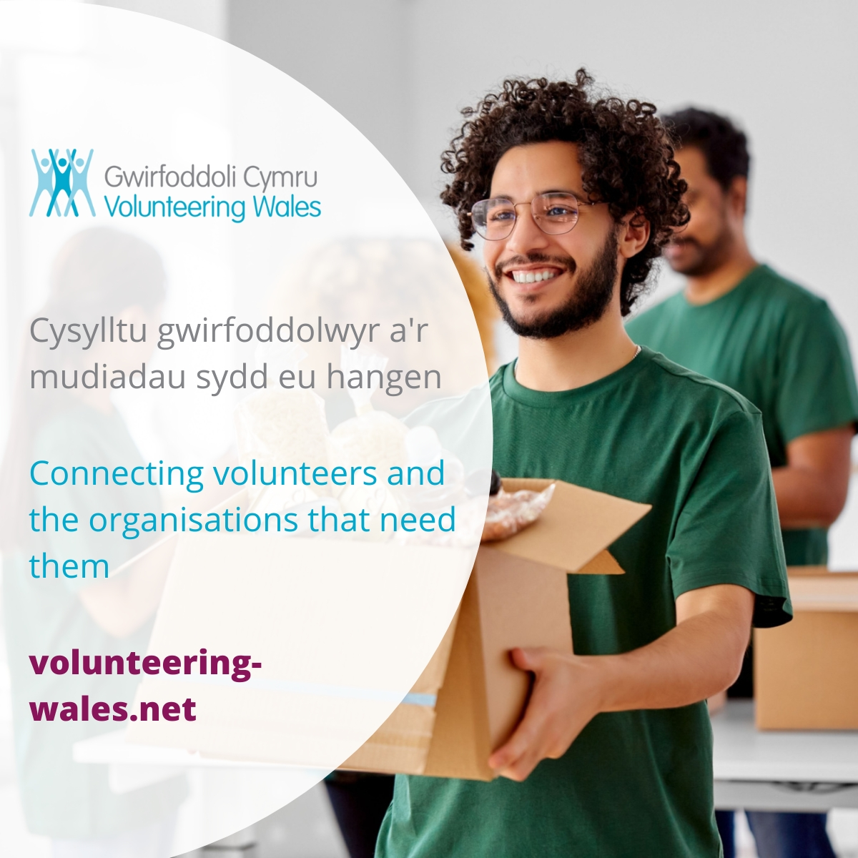

Portrait:
