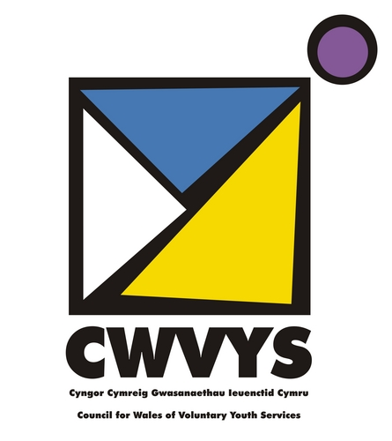

Impact of Covid-19 on the voluntary youth work sector in Wales
June 2020

Compiled by Helen Jones (CWVYS Communications Officer) and Catrin James (CWVYS Regional Coordinator)

Council for Wales of Voluntary Youth Services (CWVYS)
Baltic House, Mount Stuart Square, Cardiff, CF10 5FH
Tel: 029 2047 3498 or 07779 345703| Fax/Ffacs: 029 2045 1245
e: paul@cwvys.org.uk| w: www.cwvys.org.uk| t: @CWVYS
Registered Charity Number:1110702
Company Number 5444248
Foreword
CWVYS is the representative body for the voluntary youth sector in Wales. It is an independent charitable body that promotes quality youth work and represents the interests of its Membership and the wider sector.
As the response to the Coronavirus crisis included initiation of a nationwide lockdown in mid-March 2020, a number of our Members across the sector were forced to close down face-to-face provision. In response to this and at the instruction of our Members, CWVYS conducted a survey to assess the impact on the voluntary youth work sector in Wales.

In response to requests at recent online Regional Group meetings, CWVYS sought Members’ help in ascertaining how the current situation is affecting the sector.

We did this for three reasons:
- to understand how Members are feeling, how they are coping/not coping and the effects of working or not working during this crisis period
- to highlight areas and issues of need to which CWVYS can tailor its
support accordingly
- to share these findings as 'open data' for Members and to inform
strategic partners e.g. the Interim Youth Work Board, Welsh
Government and others about the impact of recent events on the
voluntary youth work sector

This will be important going forward to ensure we are protected as much as
possible as a sector and that its work and its contribution to society is
appreciated and valued.

Claire Cunliffe
Chair, CWVYS
June 2020
Executive Summary
The response to our survey has demonstrated that the voluntary youth sector in Wales has responded and risen to the challenge of Covid-19 swiftly and admirably, less than 8% of Members surveyed reported no operational change.
While it is clear the sector has serious concerns about the future post lockdown, many have quickly adapted their services, repurposed resources and continued to support the communities they work within. Some larger-sized CWVYS Member organisations have lost, or are projected to lose, over 9 million pounds, while smaller organisations reported they were suffering the loss of income generating projects such as cafes and nurseries, amounting to £200 - £300 a week. Such income generation is critical in contributing to core funding for those organisations. What is clear, despite the varying numbers reported, is that there is a huge amount of uncertainty regarding finances up to and beyond this financial year.
At times, the diversity of responses has obfuscated the situation in the sector; for example the response to the question about forecast up until April 2021 reads as optimistic at first glance, but we do know that the nature of youth work funding is typically short term and piecemeal, and it might be that organisations would have been ‘safe’ until April 2021 regardless of the pandemic. Indeed the follow up question on concerns about funding in future highlighted that CWVYS members were worried that grants they might usually apply for in the new financial year might have diverted their focus or have dwindling resources.
Some of our Members indicated that securing ‘Key Worker status’ for youth workers in Wales would take away some of the uncertainty around which services had legitimacy to continue, and perhaps allow front line youth workers access to equipment to allow them to continue their crucial work in safety with some of society’s most vulnerable young people.

There has been concern over the low numbers of qualifying children and young people attending schools during the crisis, and a feeling amongst our membership that if youth workers had access to those premises more of the young people they engage with might be inclined to attend.
Other Members still expressed concern that they have lost access to premises that they would otherwise rent in their localities, there is a concern that with schools needing more space to ensure correct distancing of learners, that community buildings usually offering youth work will have to be given up to schools.
With many children and young people now being homeschooled it has been noted as ironic that youth work principles of non-formal and informal learning as well as creative and innovative approaches to supporting wellbeing and challenging boredom are being attempted and applied widely. Some members felt they would be better able to support families by sharing in the care and engagement of children and young people beyond online channels.
Concerning the move to online engagement, many Members expressed that they were reaching different young people than they would usually see at their centres and projects, which was seen as positive. However some expressed concerns that the most vulnerable children and young people were either uncomfortable to engage online, or had “fallen off the radar completely”. This has been troubling a number of our Members who have built up relationships, often over years, some felt that “all that good work is being undone”.
On that subject, many of our Members have directly communicated concerns of a growing youth mental health crisis. In addition there is concern over future changes to delivery as the looming austerity of a recession is sure to signal services being cut. Further cuts to budgets and perhaps scarcity of grant funds that will doubtless imply dramatic societal and personal cost, as communities and children and young people in Wales will depend on these services more than ever before.

Executive Summary 3
WHO is affected? 6
WHAT is going on? 9
HOW has this affected things? 12
Forecast 14
Additional funding 16
Funding concerns 18
Wider Impact 20
- Young people 21
- Volunteers 24
- Community 26
The Future: Concerns 29
The Future: Opportunities 32
The Future: Recovery 35
The Future: Continuation 37
Acknowledgements 39
Out of 35 responses to the survey, encompassing almost a 3rd of our members, organisations reported 1131 staff usually employed, with 372 staff on furlough. Looking at the chart below it appears the sector surveyed has almost a quarter of staff unable to work due to the furlough scheme.
These figures are impacted upon by the fact that we know several cases where furloughed staff were unable to access email or complete surveys such as ours. It may be that the percentage of staff on furlough is higher than reported.
This is further complicated by the fact that many organisations in the voluntary youth sector employ a comparatively small number of staff compared to their large number of volunteers who deliver activities and engage with young people, so this offers a limited snapshot of the true picture of the workforce currently able to offer voluntary youth work provision in Wales.

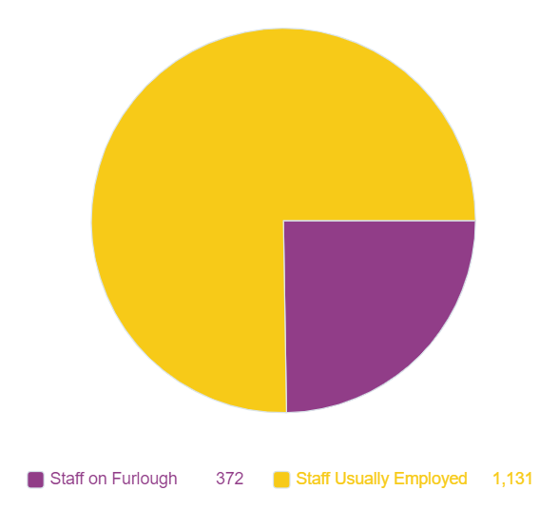

What happens when Furlough finishes?
“Closure”
While some of our members were unfortunately sure of having to close down indefinitely, others noted they were “Uncertain at present” adding that “social isolation is going to have a big impact on the way we run our provision - and we need to work out how we can act while staying safe - and give confidence to attendees, their families and also our own staff. and volunteers. We are likely to be a very different organization for the duration of the restrictions.”
A number of responders said staff would return to their roles, but some added that consideration of “what is possible with the funding available and what staff wish to return to” was vitally important. Adding that there “may be reduced hours. What contact with young people is allowed will also be a factor”.
Some reported a fear that a number of furloughed staff “may not be able to continue employment”, with at least 9 facing almost certain redundancy.
Those organisations that chose not to furlough staff offered that “funders have been happy for activities to continue online”, many echoed that most funders had been understanding of the need for projects to be paused or adapted. Though even organisations who have not accessed the furlough scheme have reported the future of their current staff is threatened, communicating the “likelihood that the hours of all our staff will reduce”. This patently poses serious questions over the future of the voluntary youth work sector and how the services young people have come to trust and engage with are threatened.
Some were slightly more positive, seeing the crisis as a learning opportunity, noting that in future “staff may continue to work from home more” with “more meetings conducted online.”
For most, the future was simply uncertain, largely dependent on when or if “usual services can resume”.

What immediate and medium term changes has the organisation made to delivery due to COVID 19?
Responses to this question were detailed and varied reflecting the diversity of the voluntary youth work sector itself. Nevertheless, we separated them out into five options: No change; Moving services online; Change or Postpone projects; Suspension of all activities; and, Repurposing resources/staff.
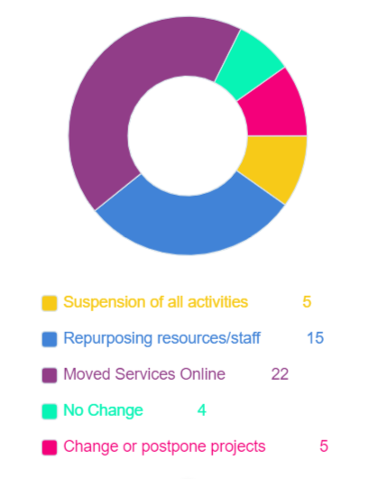
The chart above offers a picture of how some of our Member organisations adapted to the crisis in the short term. Less than 8% of organisations surveyed made no changes to their operations in the past few months. Some organisations reporting no change said that they were already “digital for our youth work”. What we did not ask was whether or not there had been a specifically increased demand of an organisations’ services, however we do know that some of our members who already have a robust digital offer have been in demand to offer advice and guidance to the sector as a whole, and have responded fantastically, indeed, one member stated: “We see great demand for the services we are able to offer in digital and transformation, but lack the funding to deliver these services. The smaller organisations do not have the funds to commission this support.”

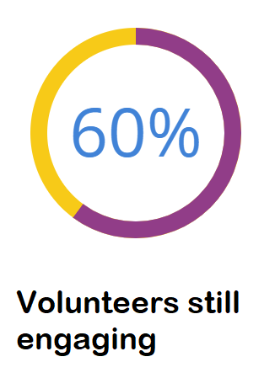

One organisation said of their 3,000 adult volunteers “We estimate that around 60% of our leaders are still engaging with young people through a variety of social media platforms”, that’s approximately 1800!

They added “we have identified that some of our volunteers are taking a break at this point in time due to a number of social, medical and emotional issues, along with a proportion of our volunteers who do not have either the skills, technology, motivation or support to deliver” online.
Other members have said of their large number of volunteer leaders that they are unsure if all will be able to continue to engage, partly due to the aforementioned issues but also due to the need for some vulnerable groups including those over 60, those from BAME backgrounds and those with pre-existing medical conditions to continue to isolate or “shield”.
Some reported that their “volunteers are no longer engaging”, while others shared that their usual volunteers were “volunteering elsewhere in the community”.

What is the immediate financial impact?
As we have a diverse range of Member organisations it has been difficult to cost the exact financial impact, both immediately and in the long term. However we were able to assess responses to the immediate financial impact and categorise them as; Little to no financial impact; Moderate financial impact; Huge financial losses; and, Unknown. The chart below shows the responses:
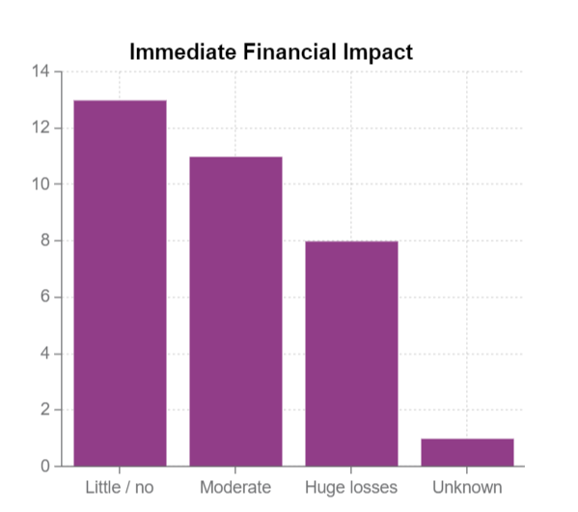
Some who reported little or no impact shared details of why this was; “As we run a food hub we have been able to draw in funding for community support. But our organisation overall would not have survived without the LA resilience grant support that has kept us solvent whilst waiting for furlough claim to be paid and covers additional costs of furloughed staff plus building costs.” It seems that even those who are doing relatively well are only managing to do so by relying on a variety of funds and adapting and continuing their provision of vital services in their communities.
Others falling in to the same category typically reported that their funders were content for projects to be adapted for online delivery where possible. Most cited the flexibility of funders as a key to their continued survival.
Others reported that accessing the UK Government’s Furlough scheme allowed them to hold on to staff in the short term without incurring big losses. This does lead to a concern as to what the situation will be like when that scheme ends.
Some reported a bleak outlook; “The financial impact is going to be major for us. We have the loss of income for our trading centre and the cost of making staff redundant; we have the loss of income which is expected through the loss of membership and the disengagement of both volunteers and young people. Financially, we are stable until February 2021 as membership which is annual was paid before lockdown. However next year, dependent on memberships we are concerned that we will have to scale down delivery, and our focus will have to be on growth and retention and support for individual units.”
What is the forecast up to April 2021?
Again it was difficult to calculate exact figures, but we were able to narrow down responses to this question into five areas: Enough funds to survive, Ok - dependant on when lockdown ‘ends’, Fine up to then/insecure post, Uncertain, and, Significant losses.
Calculating the financial impact has been difficult for our Members, reflecting the overall uncertainty of the crisis. Some noted that forecasting “is very dependent on when lockdown is eased and we are able to get back to delivering the projects we have grant funding to deliver” Others echoing “We hope to be up and running as normal by then.”
Some noted that the organisations themselves would likely survive but not without staff losses “We believe we will be fine until this date (April 2021) though we may lose a Youth Support Worker.”

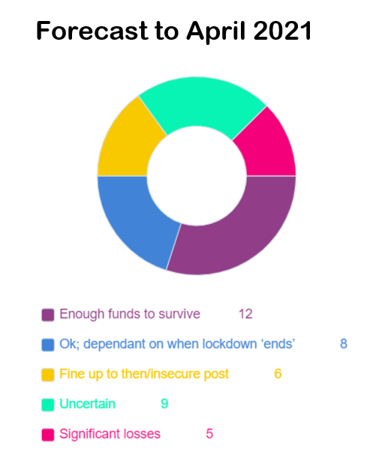

The above chart offers a visualisation of the responses received. The majority predicted survival, some had issues that were dependent on the duration of lockdown, whilst many were uncertain. Most did not offer figures, but those who were able to calculate their financial situation up until April 2021 and were able to share the numbers with us reported massive losses, such as “we are expecting a loss of £300,000” or being “likely to lose £120,000”.
What additional funding opportunities have you accessed?
Many members reported applying to numerous different funders, including from umbrella organisations like the WCVA, the various UK and Welsh Government schemes as well as applying for relief regarding business rates, utilities and so on. We separated these responses into the following categories:
- Grants and funds including Government schemes (14)
- Covid-19 Emergency Funding (13)
- Business rates/VAT relief (6)
- No need to apply / reliant on savings (4)
- Unsure (3)

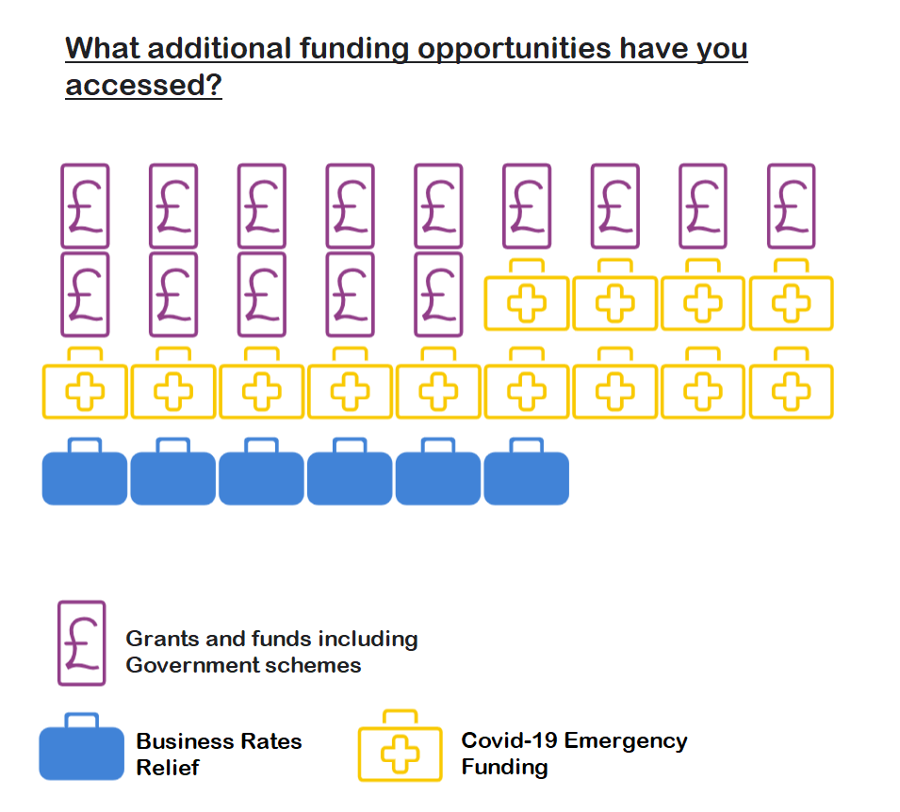

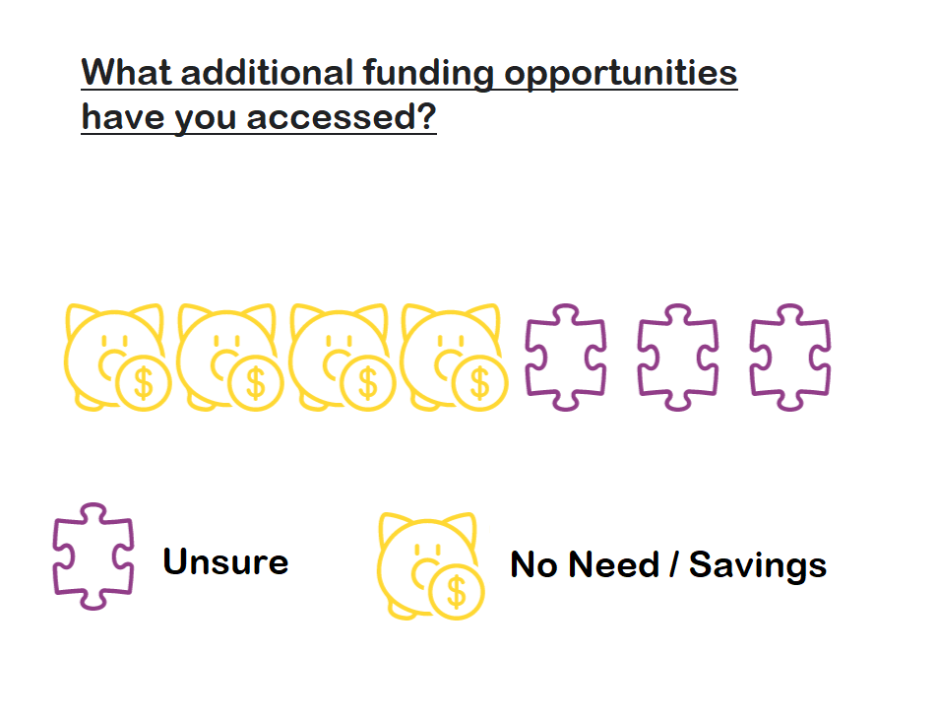
What concerns are there over future funding streams?
There seemed to be a collective worry amongst our Member organisations regarding future access to funding. These ranged from organisations uncertain whether or not they would be able to fulfil future project briefs due to restrictions on what activities can resume and what is feasible regarding compliance with social distancing measures. Some wondered “what we are actually going to be able to realistically offer to young people - and appropriate funding schemes - may be a reduced service”.
Some were particularly worried about funding pots drying up; “Will funders be able to still grant funding as their reserves will be low? Will there be a knock on effect because of austerity. Our Clubs are small entities and are losing weekly entrance fees. Although small, this money pays for insurance and utilities. Will insurance renewals go up for clubs?”
Some fears were detailed and manifold; “Closure and refocusing of funding streams that we would have applied to for planned projects. 2) Application timelines for funders may become longer, leading to gaps in funding. 3) Reduced funding available from all sources (foundations due to stock market falls affecting endowments; reductions in government support; possible reduction in lottery sales) 4) Potential for increasing paid-for / commissioned work is reduced as clients' income has also been drastically affected by Covid19.”
Some described the practical disruption the situation has had on their operations “We are in the process of sourcing additional funding to allow us to continue after April 2021 when our current Community Fund finance phase ends. Covid-19 has obviously caused some delays in this process and the concern is that we won't be able to access additional funding in a drastically altered and uncertain landscape.”
Many made reference to the “looming recession” and the effect austerity measures typically have on youth services, despite the need for quality support services in times of crisis. “There will be even more need both from organisations and the community which will make securing grants even harder than it already is. We also feel that when lockdown lifts that we will see a further increase in people needing support due to the emotional toll this has taken on vulnerable members of our communities. It is going to be a hard transition back to 'normality' and we feel that only then will we see the full impact of this crisis”.

As well as the immediate and long-term financial and organisational impact of the crisis on our Member organisations and the voluntary youth work sector directly, we wanted to listen to our Members’ thoughts and experiences about how the pandemic is having a wider impact, on the young people they work with, the volunteers they engage with and who are integral to their work, and also the impact of the virus on the communities they work within. In this section we asked three questions:

- How has it impacted on young people?
- How has it impacted volunteers?
- How has it impacted the community?

How has it impacted young people?
In looking at the effect the crisis has had on young people, many of the issues reported were seen as interlinked; having “no place to go” was seen as contributing to loneliness or isolation, or compounding some young people’s already precarious or unsafe living arrangements, all of these can be seen as having a detrimental effect on young people’s mental health and general sense of wellbeing. Unsurprisingly, the impact of the crisis on young people was reported as being unanimously negative.
We grouped replies into the emergent themes of: Lack of support/stimulation; Unemployment; Risk of homelessness / precarious accommodation; Loneliness and isolation; and, Increased mental health issues. The following chart offers a visual breakdown of responses.
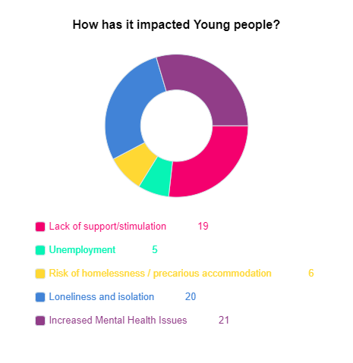
Concerning the threat to young people’s current and future employment status, and touching on a number of other issues such as lack of support and issues with accommodation, CWVYS Member The Mullany Fund offered that the impact was serious and is:
“widespread, and for our service users there is much inconsistency and uncertainty regarding their education, future plans and next steps. We work with some of the most disadvantaged young people and communities within South Wales, and already it is becoming clear that Covid-19 is having disproportionately negative impacts on these groups. A recent report, for example, from The Sutton Trust found that only 30% of A-Level students at state schools were regularly receiving work and feedback on their studies at home, compared with 57% of students at private schools. Similarly, the report found that working class UCAS applicants were twice as likely to experience difficulty in finding a suitable place to study at home than their middle class peers. It is clear, therefore, that providing consistent and reliable support is vital to ensure that these young people – our service users – remain focused on their goals and reassured that despite the current challenges, they have much to achieve and opportunities to look forward to.”
Almost all who responded to the survey explicitly mentioned concerns over the negative impact of the pandemic on the Mental Health of young people, with Loneliness and Isolation almost as frequently listed.
“Feedback has been that they are now in the situation that may cause them issues - eg: family/home life etc - 24/7 - less physical activity, missing friends, missing freedom and own space, lack of routine, and some concerns about mental health & wellbeing.”
Three separate organisations also expressed similar concerns: “We fear Young people who we have not been in contact with will be struggling at home in small houses and lack of technology to undertake school work. Mental Wellbeing is an issue.” Fearing young people were suffering with “Isolation and lack of motivation, loneliness, depression”. “Some are feeling very anxious but do not want to engage with online Zoom activities.”

How has it impacted upon volunteers?
As with previous questions, we did not wish to lead or limit Members by offering boxes to tick in the survey, instead offering the space to write as little or as much as they wished. Here again we collected their responses into themes: Uncertain, Offered a change of role, Less volunteers engaging, More volunteers engaging, and, Shielding.
Some of our Members remarked that the impact on volunteers was similar to the impact of the crisis on young people: “It has impacted volunteers in the same way as young people - mainly loneliness and isolation, as well as fears for the future.”
Others noted that “Volunteers have been desperate to help out on any way they can partly for them to have a sense of purpose and partly due to them also feeling isolated and lonely at this time.” Related to this there seems to have been a trend in volunteers switching roles and either sharing some of the work of furloughed staff or adapting quickly to more front line delivery such as putting together food parcels, offering to pick up essential supplies for vulnerable people in the community.

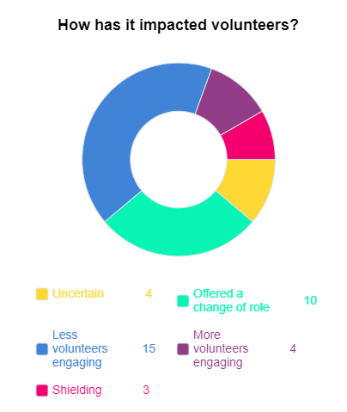

How has it impacted the community?
As with responses to previous questions, the experiences of our Members varied, with many offering nuanced responses, or suggesting that the impact had both been positive and negative, with examples of communities pulling together, but also experiencing unprecedented hardships.
We separated their remarks into 3 categories and tallied them as follows; Difficult to say (11); Negatively (17); Positively (6). The following image presents these responses graphically:
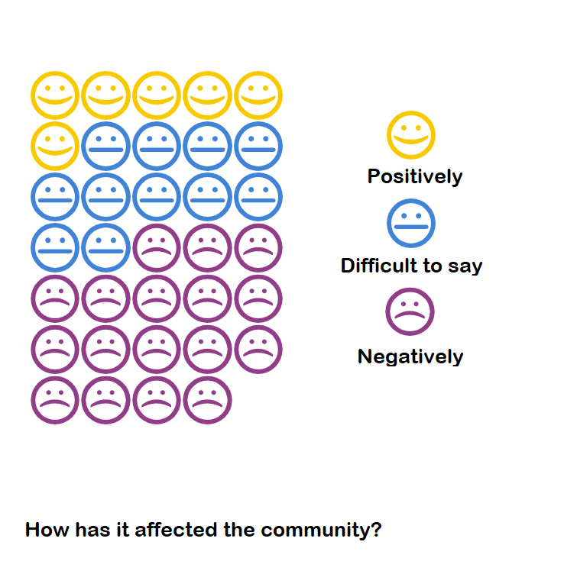
The answers to this question were overwhelmingly negative, 17 responses out of 34 were explicitly negative, with a further 11 unsure or mixed. Only 6 comments suggested a positive effect. Some Members reported that the Coronavirus had “massively” affected their communities, with one Member offering “our staff helped with the relief effort in the first few weeks of lockdown. We heard horrendous stories connected with vulnerable people especially.”
Another Member explained some of the particular issues causing stress in their communities; “I think it has been quite stressful having someone to chat to when you have problems (parents and children) those parents who are Deaf have said how difficult and frustrating it has been, particularly difficult when they come into contact with people wearing masks makes lipreading impossible”.
Some organisations shared similar worries about the effect the closure of their clubs were having on young people and the wider community; “Young people have nothing to do in their community - clubs are the hub of the communities within our membership.”
Regarding the general positive or negative impact, some described a complicated but familiar situation, sharing that the impact is “Varied - it has created a greater sense of looking out for others and has closed the door to opportunities for many in need, generally those in greatest need.”
While others took the time in their survey responses to highlight some of the heartening work going on in their communities: “It's brought the community together, there's been a lot of locally organised things like decorating streets, celebrating VE day, street bingo. We've identified that there are particular individuals who are really active in encouraging their neighbours to keep in touch and get involved (at a distance).”
Despite the good work going on however, there did seem to be a pattern of concern regarding the wider impact of Covid-19 on the communities in which our Member organisations operate. Issues such as poverty, mental ill-health and loneliness came up throughout the responses.
There is a feeling that communities are “Isolated, hungry, disconnected, lonely” as more “services close” and increasingly there are “more scams to navigate”. Fundamentally of course there are also less people accessible to offer advice and support face-to-face.
As well as these common themes, Members working in more isolated areas expressed their “concerns as to how rural communities will be affected in the long term.” Though we can report on generally shared concerns, it is also clear that the pandemic has had a disproportionate affect in different communities, with people from BAME backgrounds, the elderly and the poor at greater risk, and that the Coronavirus, rather than being an equaliser, has starkly highlighted existing inequalities in our communities.

What are your concerns?
To visualise the long term concerns our Members have with regards to the coronavirus and the ‘new normal’, we grouped their responses to the above question into four categories: How young people will be affected; How our organisation/services will be affected; Impact on the community; Uncertainty.
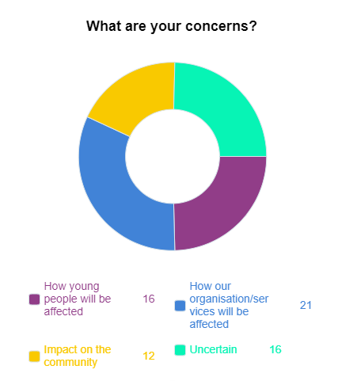
An example of how young people might be affected was offered by a Member who was “Not sure about how young people will survive without it”, “it” being access to the services usually offered before lockdown.
Another Member expanded: “We're most concerned at the impact that the virus and associated restrictions is having on our service users - specifically in relation to their educational progress and, importantly, their plans for the future. There is significant uncertainty and anxiety around 'what happens next?' for many of our young people.” They added “As ever, the most disadvantaged will experience the most negative impacts.”
Regarding the lockdown period particularly one member shared that “the restrictions are having a disproportionately negative impact on students from low socioeconomic backgrounds.” This sentiment was shared by another Member who said “This crisis will potentially increase the gap between affluent families and those on limited incomes.”
A common response was the loss of volunteers and how catastrophic this could be, as one said they “are vital for us to continue”. Another Member touched on many of the shared themes, citing their concerns as “Mental Health issues amongst young people, obesity amongst young people, austerity and lack of volunteers.” Others cited the forecast longevity of the crisis and “The ongoing impact of those who are the most vulnerable being isolated; the loss of services and opportunities; the ongoing impact of mental health issues.” Another speculated that “If lockdown continues for a longer period in time, for us, the loss of relationships with young people is our biggest concern.”
Some of our Members articulated the benefits of youth work on supporting young people’s positive wellbeing, and noted that simply moving everything online was not a ‘golden solution’. Their response also touched upon the fact that the lack of youth sector specific guidance to transitioning from lockdown is an issue. Even though the sector sits within ‘Education’, it is not appropriate or feasible to merely apply the guidelines for schools onto youth work settings without thought to adjustments that are safe for all, and which are not detrimental to the services themselves:
“Face to face work (1-1 or group work) is extremely beneficial to many of the young people we work with. It improves their confidence and self-esteem and increases their social skills. Whilst for some young people, the move online has partially replaced this, for others it has not. It is looking likely that it may be a considerable time before we are able to offer face to face group work in the way we used to, if at all. Key to this will be understanding what the risks are and how to manage the specific risks in a youth theatre or youth centre setting. These are likely to be very different from a school setting, with its much more regimented structure, students sitting at desks and moving about only at set times of the day.”
Others had immediate and long term concerns that “just opening” was a concern, overwhelmingly citing “just simply funding” or “our concerns are financial.” The possibility that funders will be focused on Covid-19 for the foreseeable future was cited as a concern for a lot of responders: “The switch to Covid 19 funding will really impact on the company and may lead to its closure at the end of the year. We were set up and planning to make several large scale bids to funding bodies , the funding opportunities were switched to Covid 19 or were put forward to next year. Even if we apply next year our organisation may close before funding can be agreed. Obviously we need to work with what is happening in our community and will try to do so , but the perilous position of project funding is harder in this environment.”
In all of these varied responses however there was always a concern about young people and “meeting the needs of the people we support.” This included concern over young people’s future prospects, “Austerity is a huge concern. Impact on young peoples’ opportunities for life in general but education/training and employment specifically.” One Member highlighted a positive result of the crisis, that fewer people were traveling the length of the country for meetings that could otherwise be conducted virtually, their concern was: “That we go back to a world where staff are expected and encouraged to travel up and down the country for a meeting.”
Are there opportunities (benefits)?
In spite of the unprecedented pressure for some of our Member organisations, their volunteers and their communities have faced during lockdown, the responses to this question were overwhelmingly positive. We grouped them into themes that stated during this difficult time some of the benefits and opportunities: Rethink how we work; Try new technologies; Greater recognition of Youth Work; Share resources and expertise; New interest in volunteering; Uncertain; None yet. The following chart shows the spread of responses:
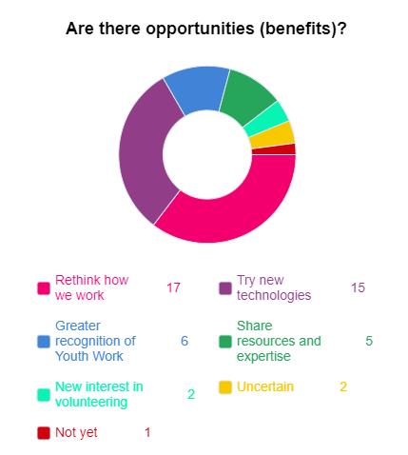
As the chart indicates, the bulk of respondents suggested that the main benefits or opportunities presented by lockdown were a chance “to rethink how we work Time to re-assess what our plans are”. A few other organisations added positively that: “It has given staff a breather to be able to further develop programmes” and that they were “taking our time and looking after our own mental health and wellbeing more. More flexible working.” One member expanded: “It does allow the organisation to consider its deliver and offer. Just because we have always delivered our services in a particular way, doesn't necessarily mean it is the right way. This time does allow us to take stock a little.”
In that reflective space, it seems that many organisations took the time to adapt their services and make use of new technologies that they had perhaps explored tentatively before now, or had been generally unsure of. Some members spoke humorously about their forays into new ways of working, that on a more serious note highlight the steps still needed to ensure technology is as inclusive as possible: “Well we are looking at different ways of doing things … We have tried a Zoom meeting it was hilarious but not conducive to BSL”
Adaptations and internet connection permitting, some Members ventured that there was potential for tackling isolation in rural areas by using social media platforms: “we have for a long time spoken about digital groups for young people in hard to reach rural areas and this has given us a chance to see if it works”. Lockdown presented the opportunity to test this out, and may well have offered further chance to re-evaluate current ways of working. Many shared words to the effect that: “We have developed skills and expertise in delivering some of activities online.”
With further regards to technology, some Members with more experience of digital youth engagement wrote enthusiastically about the potential for sharing knowledge and expertise:

“With the majority of our services already digital, we've really enjoyed working more closely with other organisations to share best practice, pool resources and ensure that we are all sign posting services so that all of our service users are receiving as much and as relevant support as possible. We've also taken the opportunity to expand our mentoring, offering it to schools outside of our target regions and to students who have more general plans and aren't entirely certain of a career within the life sciences.”
Many respondents remarked that the period has provided “Time for reflection. Opportunity to consult with service users and the community on what the needs are”. In the spirit of this reflection and appreciation of community needs, another wrote: “Hopefully governments will see the value of youth work and the programmes helping the mental wellbeing of young people.” Further to the hope that youth work’s value could be appreciated more, one member remarked of the opportunity: “To gain the greater support of parents after this because the services provided were visible to the parents. They can now see what we do and how this supports their children.”
Just two respondents directly mentioned there was an increased interest in people volunteering, with one writing cautiously yet optimistically that the: “Community has changed but not sure whether it will stick. We have gained some good volunteers. As an organisation we have grown in stature locally. If we survive these will be benefits.”
For those who said they were uncertain, one Member explained there were no benefits: “unless in the future funders look hard at what is required. It’s very difficult to look at these benefits yet, in the "bigger picture" On the face of it families should benefit from the time spent together however no one knows what happens behind closed doors and we can only imagine that at some point relationships will become strained?”

How long will it take to recover?
Some remarked that they were “confident that we can respond to changing circumstances and new government advice fairly quickly and it will not take us long to resume usual (if slightly altered) services once it is appropriate to do so” Others similarly writing: “We are flexible and dynamic and will adapt quickly” or “Depends on government guidelines.” Other respondents gave specific quantitative responses.
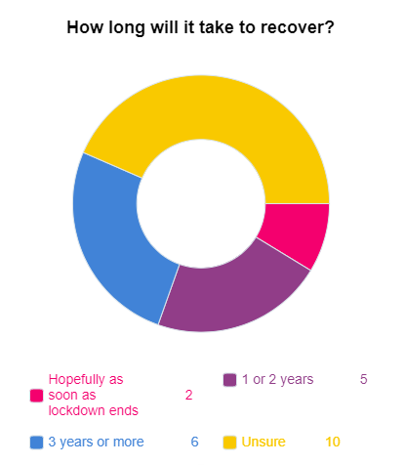
Based on this, we decided to group responses into four categories: Hopefully as soon as lockdown ends; 1 or 2 years; 3 years or more; and, Unsure.
The responses were relatively brief and rather mixed. Some shared that “For us personally we like to think that as soon as this crisis is over we can resume normal services.” While others were more conservative and estimated that recovery might take “Until 2022 subject to us receiving suitable funding”, or “24 months or longer dependant on the ability for us to gain rental income”.
Some said that recovery was “Starting now. It feels like until we have immunisation we will not get there.” While another organisation said recovery would take “5 years”. Many others were unable to envisage a timetable, stating they were “Unsure as in one is very uncertain” or asked “How long is a piece of string.....endless”.
Less than 10%, or only 2 out of 23 respondents were hopeful of a swift return to operating as before. Whereas 16 out of 23, over half, predicted recovery being a drawn out process.

Will you be able to continue as before?
This was perhaps a difficult question for members to answer, and in some ways thoughts about continuation of services were gathered and covered in previous questions. Responses to ‘Will you be able to continue as before?’ were typically brief, no more than a couple of sentences, the majority one or two words such as “It’s unlikely” or “yes hopefully”. We separated them in to the categories: Yes; Hopeful / Likely; Unsure; Doubtful / Unlikely; and, No.
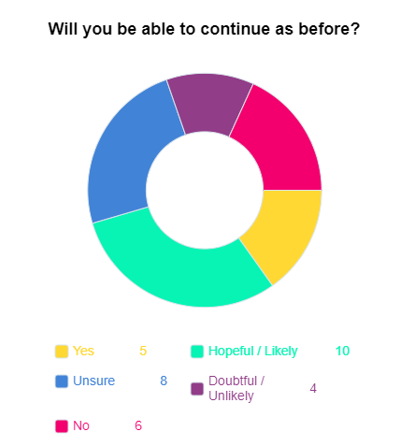
One of the responses that could have fitted ‘hopeful’ and ‘unsure’ shared: “That depends on how affected our children and young people have become over this period. We hope so but we also recognise that extra services may have to be brought in to support our client groups.”
Another response that fitted both ‘yes’ and ‘hopeful’ stated that the answer to the question of continuation was: “Broadly speaking Yes, but with some changes to the way in which we deliver services and some added safeguards. It is envisaged it will be a slow and steady series of gradual changes.”
Some were able to calculate the number of club closures but were nevertheless optimistic: “Hopefully we will embrace the technology as a head office but hopefully clubs will resume. We estimate that 10% will not reopen initially due to health issues of volunteers.”
The ‘No’ responses were typically the most pessimistic. However, even some of those who responded with a No had some hopeful responses: “No - we will continue to innovate and transform our services to young people and services.” Overall it does show that more than half of respondents were uncertain of being able to continue as before, with sadly almost a third of respondents predicting continuation as unlikely or not possible.

We are grateful to all who responded to our survey, given the demands on peoples’ attention and the increase in stress and uncertainty over the last few months, the fact that our Members took the time to respond is not something we have taken for granted. Thank you to those Members who supplied us with a wealth of information, we hope this report has been useful to all CWVYS Members and the wider sector.
We aim to continue this survey quarterly this financial year.
If the issues raised in this report resonate within your organisation, or you see opportunities for engagement and support across the sector, you can find a list of CWVYS Members on our website: https://www.cwvys.org.uk/members/
We are sure Members would welcome the connection. The value of the sector is in its Members and how you support each other.

