**Who is it for?**

Community musicians with some experience of workshop leading in community settings, who would like to increase their knowledge and skills to work in mental health settings.

Musicians with experience as Mental Health professionals or service users who would like to bring their musical experience into mental health settings.

**The course will cover:**

* Creating, adapting and leading appropriate musical activities for people with mental health problems
* Increasing confidence in working with vulnerable or distressed people
* Understanding the boundaries of the role of a community musician; what is and isn’t your responsibility, when to ask for help.
* How to include and empower people in groups
* An introduction to some of the issues faced by mental health service users.
* Group leadership and development
* Planning and flexible working
* Managing expectations in groups
* Communicating effectively with agencies and institutions
* Giving and receiving feedback, including reflecting on own practice.

N.B. The course will not cover diagnosing or curing mental health conditions or music therapy training.

As well as tutor-led practical exercises and discussions, there will be a strong element of shared and collaborative learning, with small and large group tasks, teaching practice and research. We will also encourage structured feedback reflective practice as a lifelong tool for best practice.

Alongside the course, trainees will be offered the opportunity to attend a placement in an existing community music workshop in a mental health setting.

Community Music in Mental Health Settings

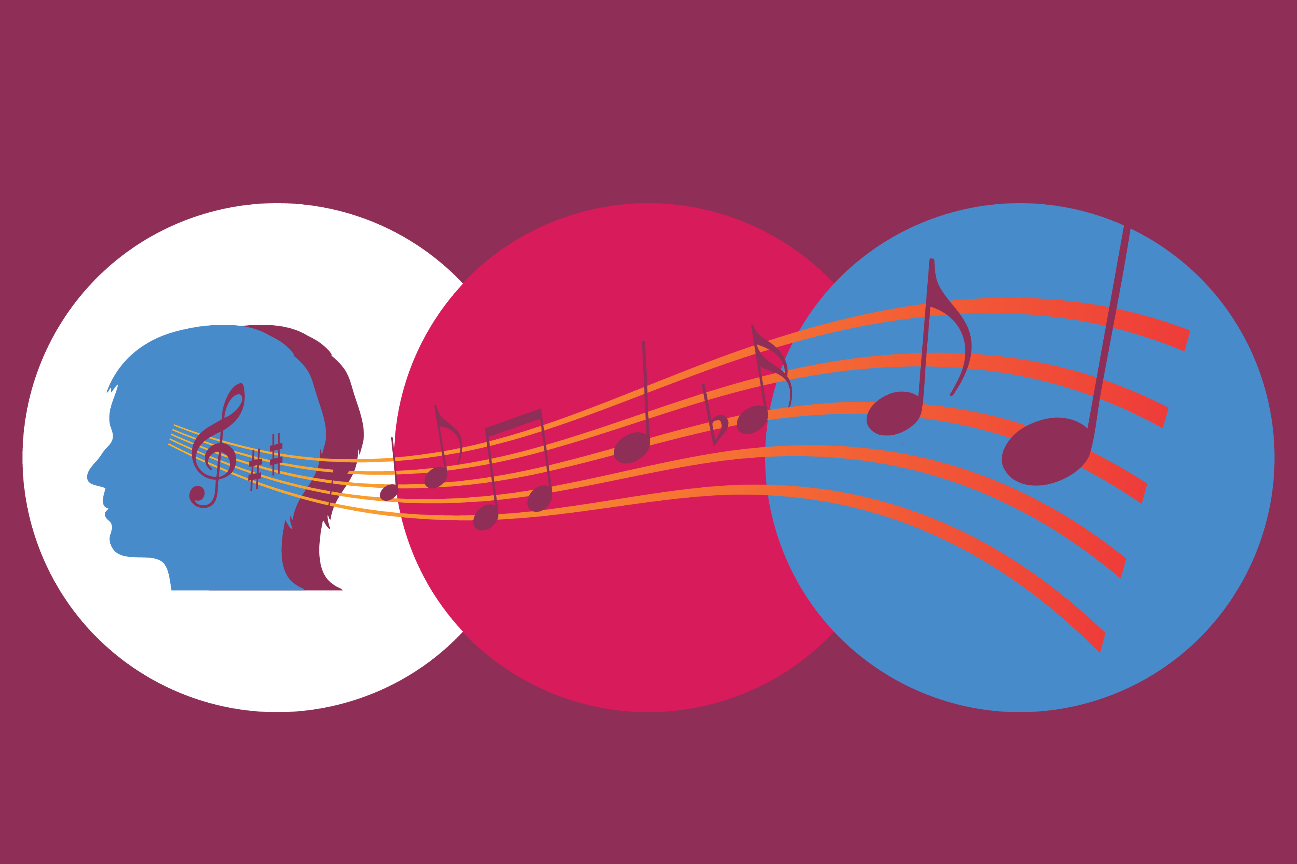



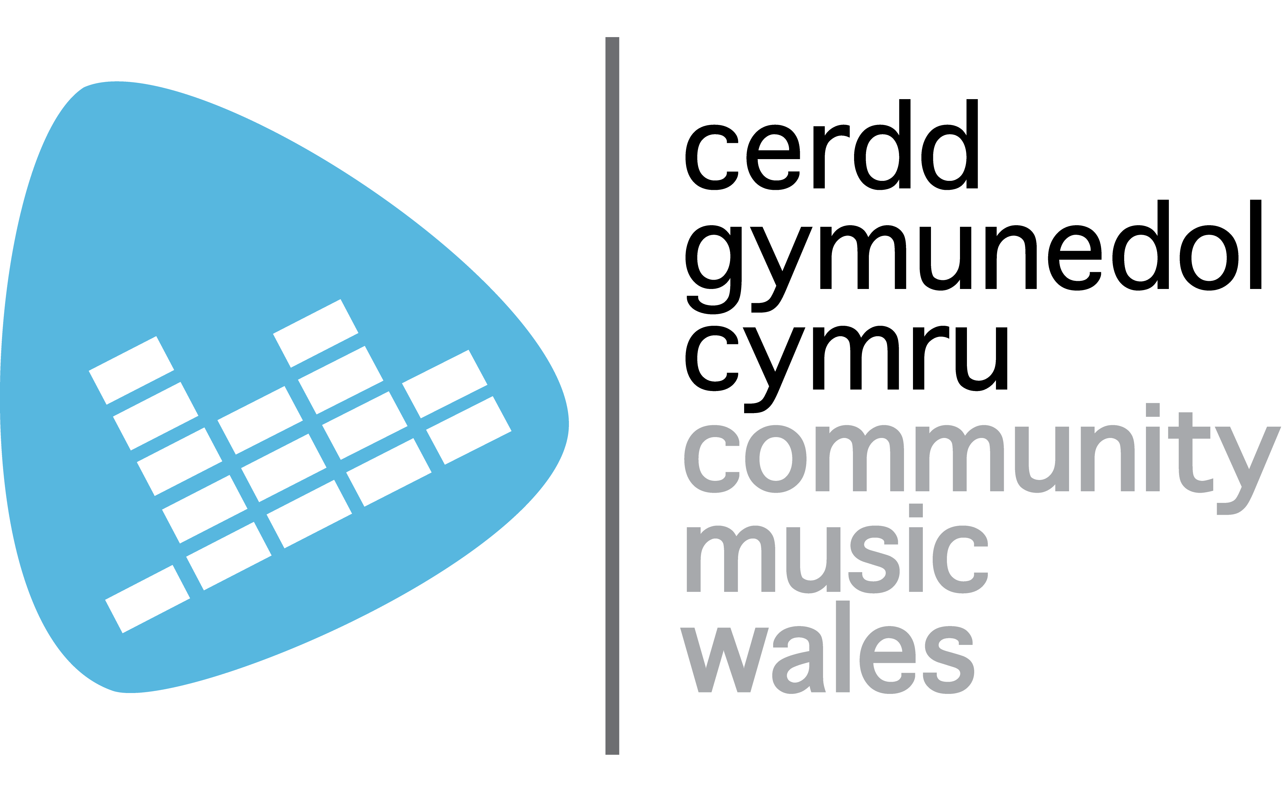

**Outline**

**Session 1**: Intro to course, ground rules, including confidentiality. Intros to each other and experience, self-assessment. What is mental health? Statistics on incidence of mental illness and attitudes.

**Session 2**: The role of a community musician in mental health settings, boundaries, asking for help, keeping yourselves and others safe. Possible relevant video of experience and what this means for our work.

**Session 3**: Adapting and creating musical activities. What is the same and what is distinctive about working in mental health settings? Sharing experiences, adapting exercises to suit the context.

**Session 4**: Adapting and creating musical activities part 2. Pair/small group tasks.

**Session 5**: Planning/flexibility – importance of planning (avoiding disasters). Need for flexibility.

**Session 6**: Working with agencies - communicating with agencies to ensure effective practice, dealing with problems, assertiveness.

**Session 7**: Teaching practice

**Session 8**: Teaching practice

**Session 9**: Dealing with challenging situations – Case studies e.g. dealing with group member not participating, someone in distress, someone being aggressive and threatening, someone unable to focus (possibly due to drugs or alcohol).

**Session 10:** What next – putting skills into practice- project planning, self-assessment, peer assessment. Final questions.

**Course Dates:**

Cardiff – June 10th, 11th, 17th, 24th, 25th

Carmarthen – July 10th, 18th, 22nd, 23rd, 24th

Rhyl – September 9th, 10th, 16th, 23rd, 24th