 | 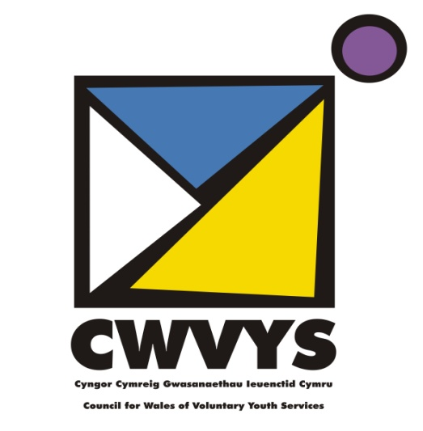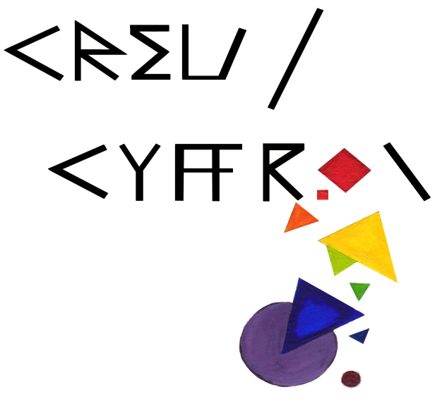
Application Form for CWVYS CREU / CYFFROI
Bursary 2018-19
 | Name of Your Organisation
 | Address of Organisation
 | Telephone: Phone:
 | Email
 | Please give an overview of your proposed project and how it links to the brief:
 | How many young people will benefit from this bursary? |  |  |  |  |  | How many volunteers will benefit?
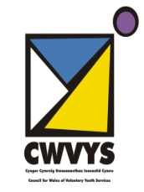

What activities will the bursary cover?

Please provide the cost breakdown for each element

Please provide any further information that you think might assist us when assessing this application.

Name

Signature

Date

Send your completed application form by post or email and by no later than September 5th 2018 to:
Helen@CWVYS.org.uk
Helen Jones
Projects and Membership Officer
CWVYS
4th Floor, Baltic House
Mount Stuart Square
Cardiff
CF10 5FH

