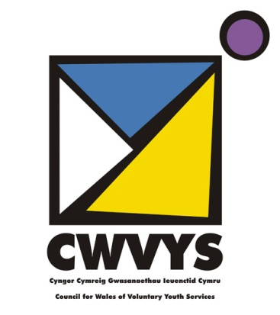 |  | HAENAU TÂL AELODAETH  MEMBERSHIP SUBSCRIPTION BANDS  2015-2016

Annual membership fees

Community / Local Voluntary Youth Organisations | £37

National Voluntary Youth Organisations

membership of less than 1000 | £74
membership between 1000 – 5000 | £119
membership between 5000 – 15000 | £144
membership of more than 15000 | £227
Umbrella organisations | £227
ORGANISATIONS WITH INCOME OF LESS THAN £1000 p.a. | Free  (year 1 only)

Mudiadau Ieuenctid Gwirfoddol Lleol /Cymunedol | £37

Mudiadau Ieuenctid Gwirfoddol Cenedlaethol

Mudiadau ag aelodaeth o lai na 1000 | £74
Mudiadau ag aelodaeth rhwng 1000 – 5000 | £119
Mudiadau ag aelodaeth rhwng 5000 – 15000 | £144
Mudiadau ag aelodaeth dros 15000 | £227
Cyrff ambarel | £227
Cyrff gydag ychydig neu dim cyllid (llai na £1000) | Yn rhad ac am ddim am - flwyddyn yn unig

